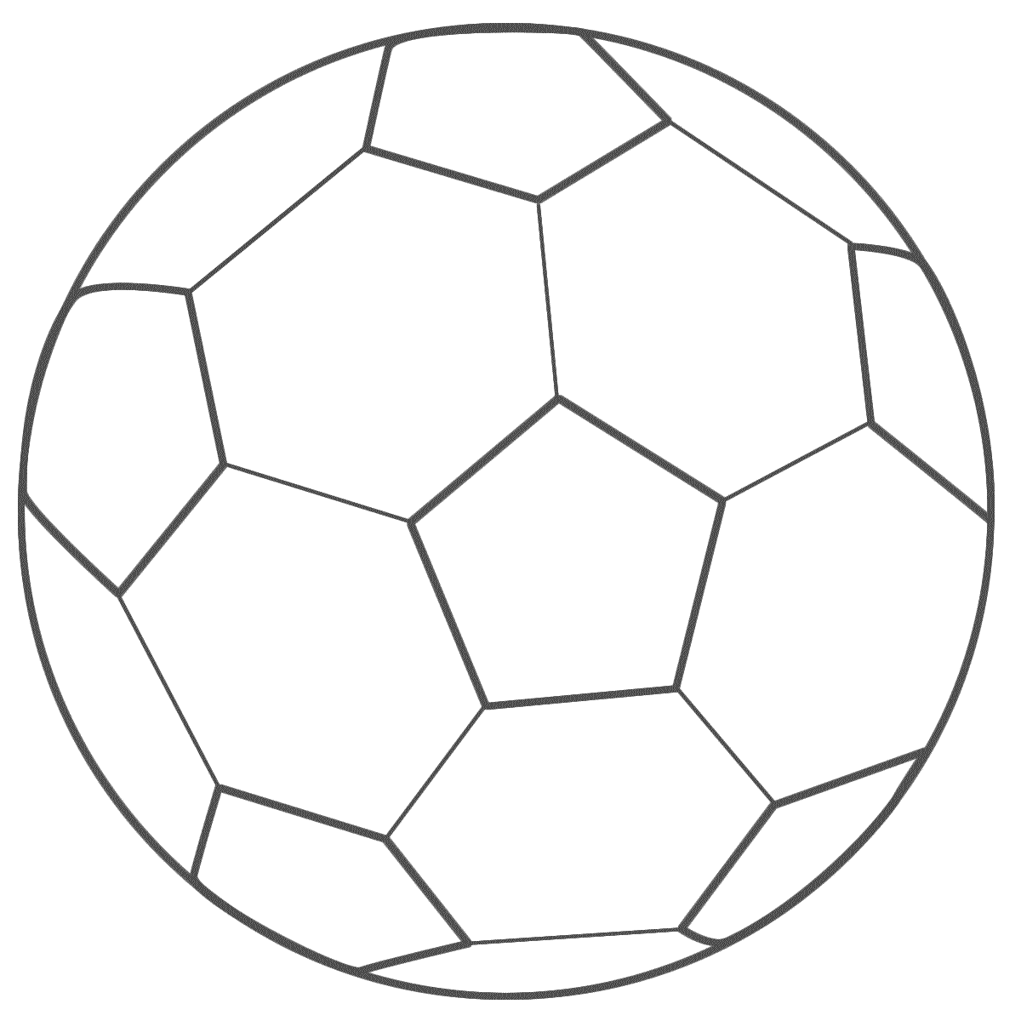

Name: ____________

People who can help me are:

I will do this by:

I will do this by:

At home, I will get better at:

In school, I will get better at:

Goals!